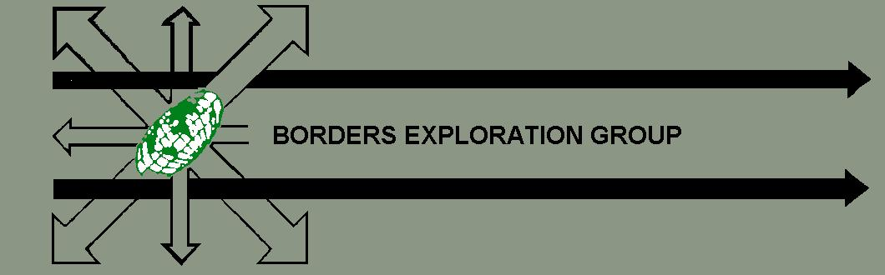

TEAM REGISTRATION FORM

Name of Team……………………………………………………………………………………………………..

Name of Business/Organisation you are Representing
…………………………………………………………………………………………………..

Name of Team Manager………………………………………………………………………………………

Address………………………………………………………………………………………………………………………………………………………………………………………………………………………………………………………………………………………………………………………………………………………………………………………………………
Contact Tel No. Home……………………………..Work…………………………………………..

Email address……………………………………………………………………………………………………………

Name (Print)…………………………………………………………..
Signature…………………………………………………………………

The registration fee of £160 must be sent with this form by April 30th to secure your place on the event. A receipt will be issued which will confirm your team’s acceptance. If you experience difficulties near the event with team members dropping out please get in touch, as we are often able to help in filling places. It is important that teams do not pull out at the last minute or fail to turn up on the day as it affects the success of the event for all involved.

Please send this form with your fee of £160,to

Nancy Anderson, Mosspark, West Morriston, Earlston Berwickshire TD4 6AZ Tel 01896 849362 Mobile 0779 222 1449
Cheques should be made payable to Borders Exploration Group

